**Flutter Prototype Designing**

**Sara Masood**

**you need to make the following pet UI Prototype in flutter deploy your assignment on firebase and add git repository as well. All assets are uploaded with attached zip file.**

**Group 1: Pet UI**

**Group 2 News UI**

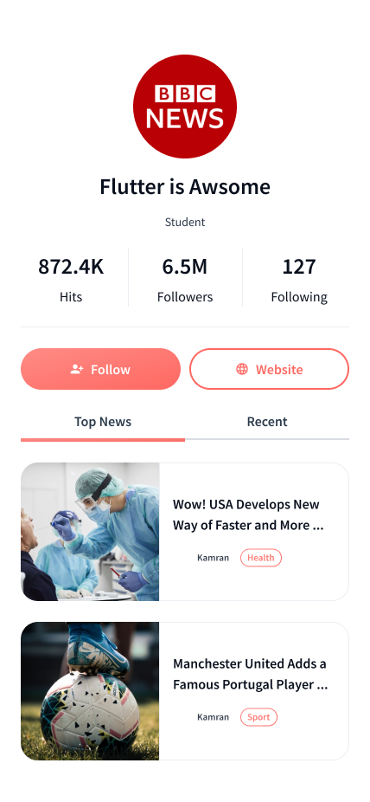

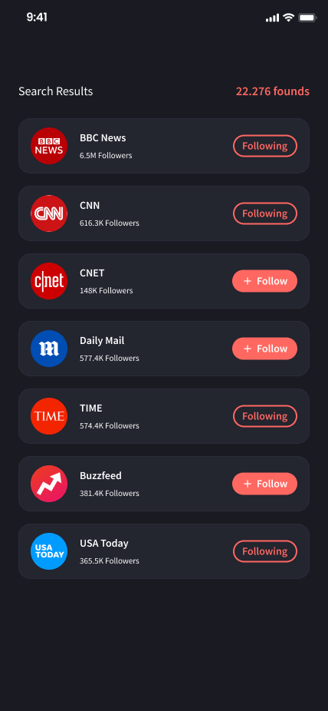

**Group 3 Banking UI**

